Briefing from Baby Lifeline
Getting the fundamentals right for women, babies, and staff: Challenges, Solutions and Maternity Services in Your Constituency

Maternity Services in the UK: The Challenges
Avoidable harm and death: NHS maternity services are in crisis due to high levels of avoidable harm and death, cultural problems, poor staff retention and a slow pace of change. Every day in the UK, thirteen babies are stillborn or die within their first four weeks of life [1]. Every four days a family is left motherless due to causes relating to their pregnancy [2]. Research shows that many of these mothers and babies may have had a different outcome with different care [3, 4].
We know that there are many examples of excellent maternity care happening across the UK, and that staff work incredibly hard to provide quality care to families. However, maternity services need support and investment in order to be able to safely deliver their vital work.
Unmet targets: In 2017, the government set out aims to halve stillbirths, neonatal and maternal deaths, and neonatal brain injuries by 2025 [5]. These targets have not been met [6]. Black and Asian women and babies have the highest mortality rates, and outcomes are also worst for those from the most deprived areas [3, 4]. There are a number of significant challenges facing maternity services today.
Safer staff, safer care: As well as the avoidable deaths and injuries of mothers and their babies, another pertinent challenge to maternity safety is staffing and morale. A 2021 survey by the Royal College of Midwives found that 57% were considering leaving their role in the next year. Of these, 84% were concerned about staffing levels and two-thirds were not satisfied with the quality of care they are currently able to deliver [7]. The most recent statistics published by NHS England show that between January and September 2024, midwives had the second highest sickness absence rate amongst professionally qualified clinical staff groups after paramedics. Anxiety, depression, stress or other psychiatric illnesses were by far the most frequently cited reason for absence (25-35%) [8]. Safe staffing is essential for safe care.
The Cost of Harm: A further challenge is the financial cost of avoidable harm, in the form of negligence claims. The nature of maternity services means that payments often need to cover life-long care and individual cases can cost tens of millions of pounds. 13% of claims received in 2023/2024 (in England) were related to obstetrics, but this accounted for 57% of the £6.6 billion total value – £3.7 billion [9]. This is comparable to the cost of delivering all babies and antenatal care (see chart below).
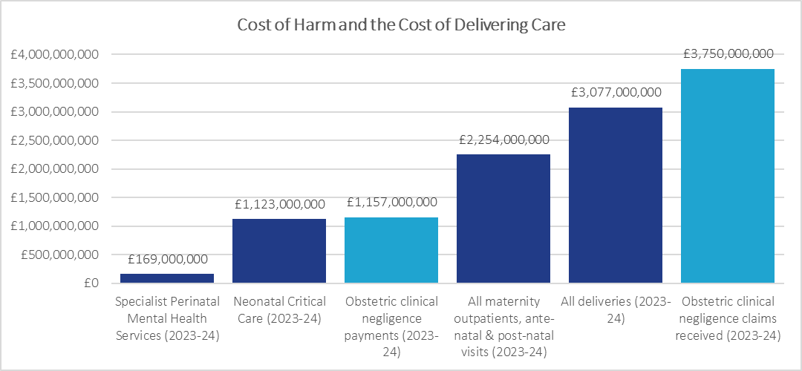
Sources: National Cost Collection Data (2021-22) and the NHS Resolution 2023-24 Annual Report

Getting it right for mums and babies is also key to building a healthier population: pregnancy and the first years of a baby’s life are crucial to determining their lifelong health [10]. Healthier pregnancies and safer births mean money saved in the long run.
Your Local Data
The data for the trust local to your constituency, Nottingham University Hospitals NHS Trust, shows that there were 49 perinatal deaths in 2022 (out of 7584 births). In 2023-24, NHS Resolution paid £10,275,536 in litigation costs to families that experienced maternity care at NUH.
Not only do these numbers represent a significant amount of taxpayers’ money that could be better spent on services, but every tragic outcome leaves behind a devastated family and demoralised staff who are striving to provide the best possible care in very difficult circumstances.
Maternity Services in the UK: Getting the Fundamentals Right
Resources, training and hospital facilities – the fundamentals – must be improved so that staff can deliver essential care and feel valued.
Investment in services: The government must be prepared to fund services upfront to save money in the long run. The value of obstetric clinical negligence claims received by NHS Resolution is comparable to the combined cost of delivering every baby in England and providing all antenatal scans and procedures (see chart above). If we were to prevent just a few of these deaths and injuries, the NHS would have a lot more money to invest in maternity and neonatal services in future, and families and staff would not have to face devastating outcomes.
Equipment and resource: When we surveyed health professionals working in the NHS in 2024, over two thirds told us that they had worked in units where vital equipment was either unavailable or broken when they needed to use it. Last year the Care Quality Commission (CQC) released a review of maternity services in England: no maternity services were rated “outstanding” for being safe, and almost two-thirds were rated as “requires improvement” or “inadequate” [11]. The report found that “some maternity units were not fit for purpose, and lacked space and facilities, and in some cases appropriate levels of potentially life-saving equipment” [11].
Addressing the causes of avoidable harm through training: For decades, ongoing CPD training has been a central recommendation for improvement, and yet our research has consistently shown detrimental gaps in training relating to the causes of avoidable harm and improving health inequalities [12]. Our research shows that:
- The main barriers to providing fundamental staff training for maternity staff relate to a lack of resource (whether that be funding, staffing, equipment or venues)
- Though the main causes of maternal mortality in the UK have remained unchanged for over a decade, there is no correlation between these causes and training provided to maternity staff
- There is significant variation in levels of implementation of the training elements of the Saving Babies’ Lives Care Bundle, a set of evidence-based mandatory actions (for NHS trusts in England) to reduce perinatal mortality
- Only a third or less of NHS maternity providers deliver training tailored to ensuring that maternity staff have the skills to competently communicate with, advocate for, and recognise deterioration in mothers and babies from diverse backgrounds.
A Parliamentary Roadmap for Progress
In 2021, the Health and Social Care Select Committee issued a report evaluating the Government’s progress against its policy commitments towards maternity services in England. It found that three of the four policy areas required improvement: maternity safety, continuity of carer and safe staffing. The fourth area, personalised care and support plans, was found to be inadequate [13].
The new Government must work with senior leaders to work to improve maternity services – including addressing health inequalities – to reduce preventable deaths and ensure that the UK is one of the safest places in the world to give birth.

About Baby Lifeline
Baby Lifeline is a unique national mother and baby charity whose mission is to improve safety and care in maternity services. We do this by providing equipment, carrying out research, and developing and providing training.

References
[1] Office for National Statistics (ONS), released 31 May 2024. Child and infant mortality in England and Wales: 2022 [accessed 20 February 2025].

[2] MBRRACE-UK. Data brief: Maternal mortality UK 2021-23, released January 2025. https://www.npeu.ox.ac.uk/mbrrace-uk/data-brief/maternal-mortality-2021-2023 [accessed 20 February 2025].

[3] Allison Felker, Roshni Patel, Rohit Kotnis, Sara Kenyon, Marian Knight (Eds.) on behalf of MBRRACE-UK. Saving Lives, Improving Mothers’ Care Compiled Report - Lessons learned to inform maternity care from the UK and Ireland Confidential Enquiries into Maternal Deaths and Morbidity 2020-22. Oxford: National Perinatal Epidemiology Unit, University of Oxford 2024. MBRRACE-UK Maternal MAIN Report 2024 V2.0 ONLINE.pdf [accessed 20 February 2025].

[4] Gallimore ID, Matthews RJ, Page GL, Smith LK, Fenton AC, Knight M, Smith PW, Redpath S, Manktelow BN, on behalf of the MBRRACE-UK Collaboration. MBRRACE-UK Perinatal Mortality Surveillance, UK Perinatal Deaths of Babies Born in 2022: State of the Nation Report. Leicester: The Infant Mortality and Morbidity Studies, Department of Population Health Sciences, University of Leicester. 2024. State of the nation report | MBRRACE-UK [accessed 20 February 2025].

[5] Department of Health. Safer Maternity Care - The National Maternity Safety Strategy - Progress and Next Steps. 28 November 2017. https://assets.publishing.service.gov.uk/media/5a74eacbe5274a3cb286839b/Safer_maternity_care_-_progress_and_next_steps.pdf [accessed 20 February 2025].

[6] Bukky Balogen, Manjit Gheera, Rachael Harker and Katherine Garrett. ‘Research Briefing: Quality and safety of maternity care (England).’ 19 February 2025. https://commonslibrary.parliament.uk/research-briefings/cbp-9815/ [accessed 20 February 2025].

[7] Royal College of Midwives. ‘RCM warns of midwife exodus as maternity staffing crisis grows.’ 4 October 2021. https://pre.rcm.org.uk/media-releases/2021/september/rcm-warns-of-midwife-exodus-as-maternity-staffing-crisis-grows/ [accessed 20 February 2025].

[8] NHS England. NHS Sickness Absence Rates, September 2024. 30 January 2025. NHS Sickness Absence Rates, September 2024 - NHS England Digital [accessed 20 February 2025].

[9] NHS Resolution. Annual report and accounts 2023/24. 23 July 2024. NHS Resolution annual report and accounts 2023 to 2024 [accessed 20 February 2025].

[10] HM Government. The Best Start for Life. A Vision for the 1,001 Critical Days. The Early Years Healthy Development Review Report. 2021. https://assets.publishing.service.gov.uk/media/605c5e61d3bf7f2f0d94183a/The_best_start_for_life_a_vision_for_the_1_001_critical_days.pdf [accessed 20 February 2025].

[11] Care Quality Commission. National review of maternity services in England 2022 to 2024. 19 September 2024. https://www.cqc.org.uk/publications/maternity-services-2022-2024 [accessed 20 February 2025].

[12] Ledger S, Hindle G, McKee A, Smith T. Mind the Gap: An Investigation into
maternity training for frontline professionals across the UK (2020/21). Baby Lifeline, UK. November 2021. https://www.babylifeline.org.uk/wp-content/uploads/2021/11/Mind-the-Gap-2021-Baby-Lifeline-Full-Report-v1.3.pdf [accessed 20 February 2025].

[13] House of Commons, Health and Social Care Committee. The Health and Social Care Committee’s Expert Panel: Evaluation of the Government’s progress against its policy commitments in the area of maternity services in England. First Special Report of Session 2021–22. 30 June 2021. https://committees.parliament.uk/publications/6560/documents/71747/default/ [accessed 20 February 2025].

